How to post your Facilities/bonus’s into a group

1. Fill your Facilities as you would normally do.
2. When you go to post them make sure you put something in the top box (I number bonus’s or ingredients or put letters doesn’t matter as this just makes sure that the post ends up on your wall).
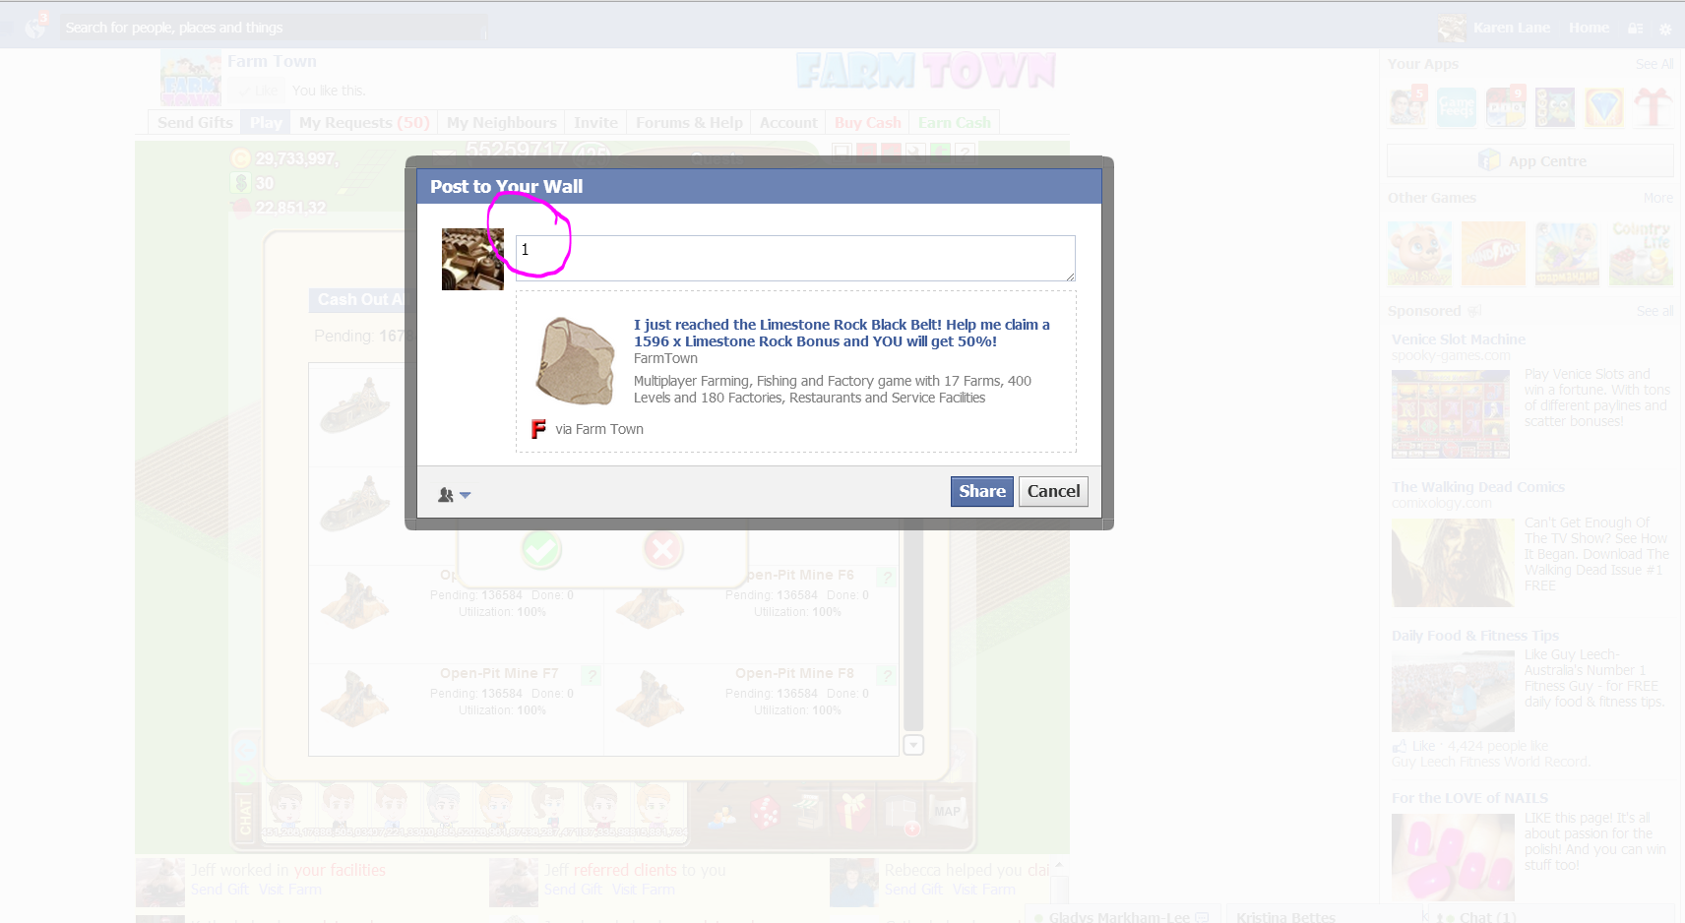
3. Once you have finished and are ready to post to a group go to your profile page.
4. Because you typed in that to box you will now see it on your profile page like this.
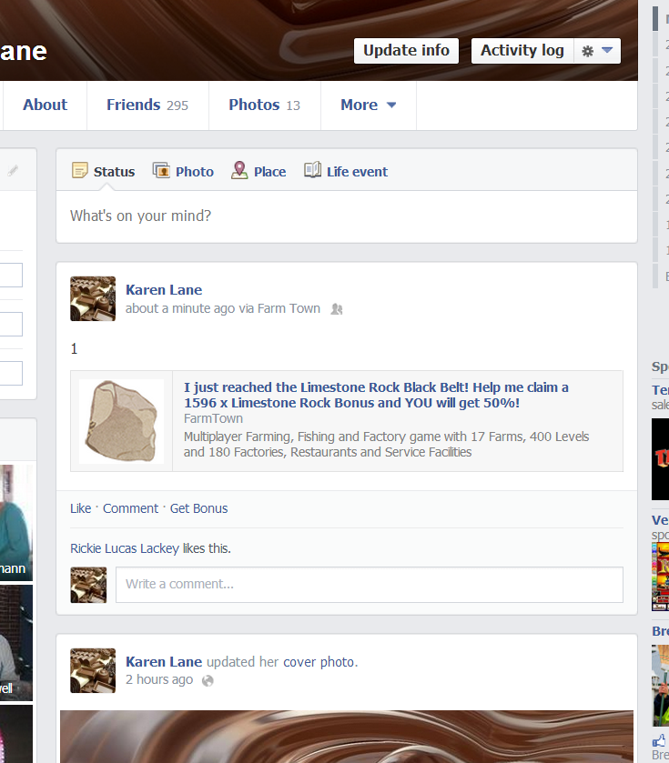
5. Now you need to right click on the “blue writing” of the post and click on “copy link address”
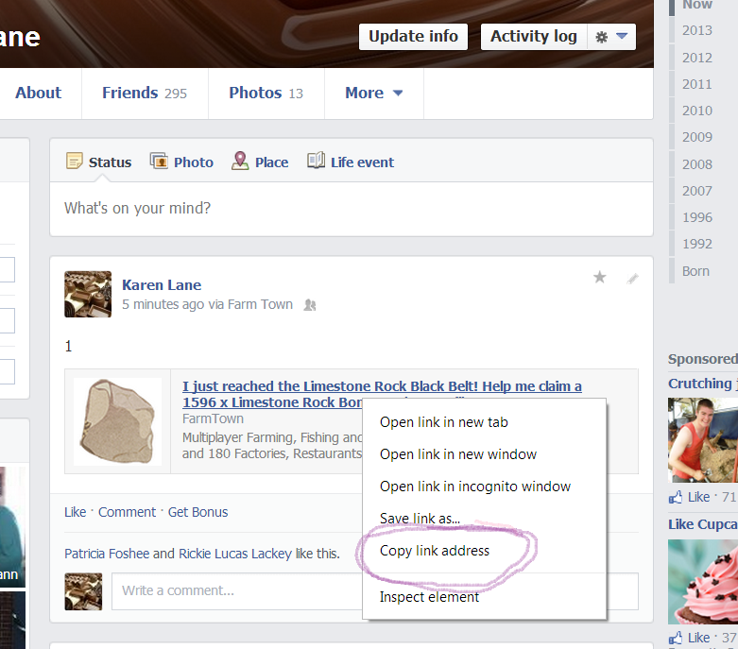
6. Open a tab for the group that you want to post into. For Bonus/Ingredients go to Wow Bonus/Ingredients group or for Facility/Clients go to Wow 25’s whichever you are a member of.
In the top box right click then select paste
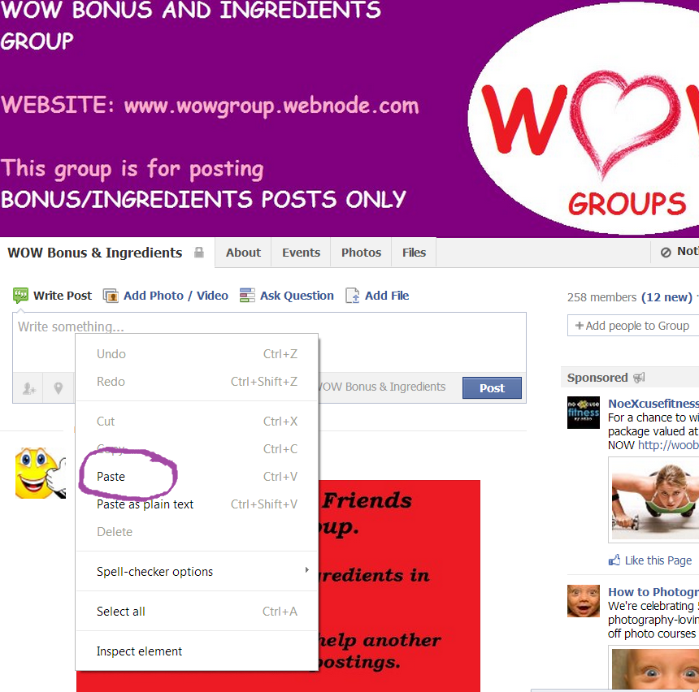
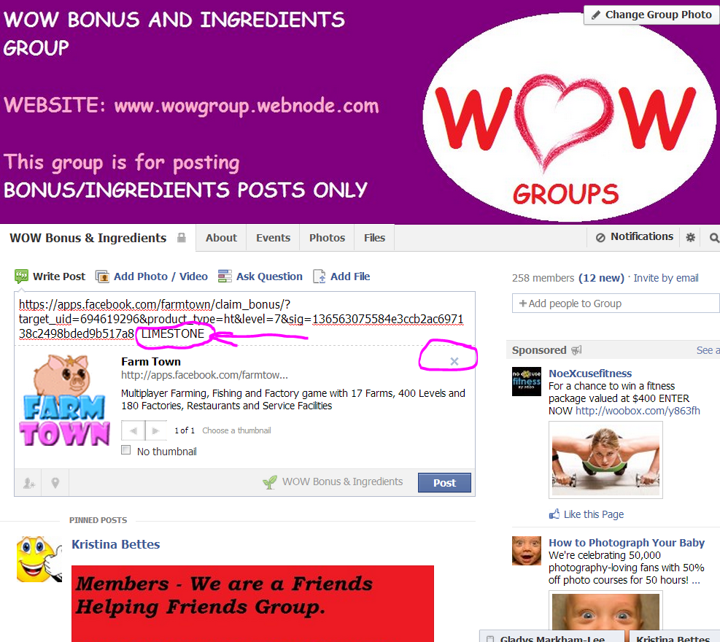

UPDATE AS OF JUNE 9TH: THE ‘X’ FOR THE PIG/FT BOX HAS MOVED. SEE THIS PIC ON HOW TO REMOVE IT:
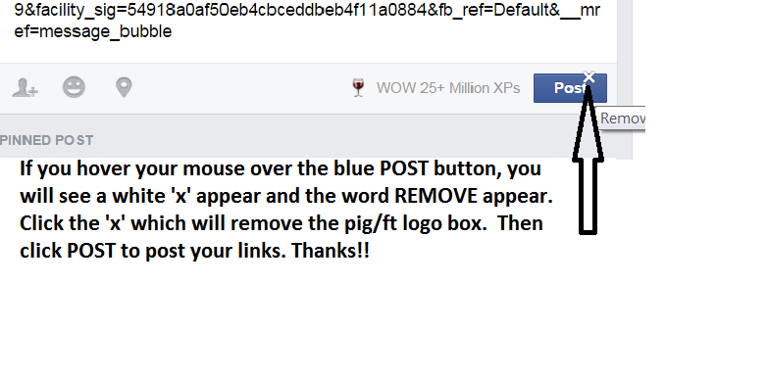
7. Next to the link write what it is (I use capitals so I can see the difference when I am working) and also click on the little “x” underneath in the box that the “pig” is in.
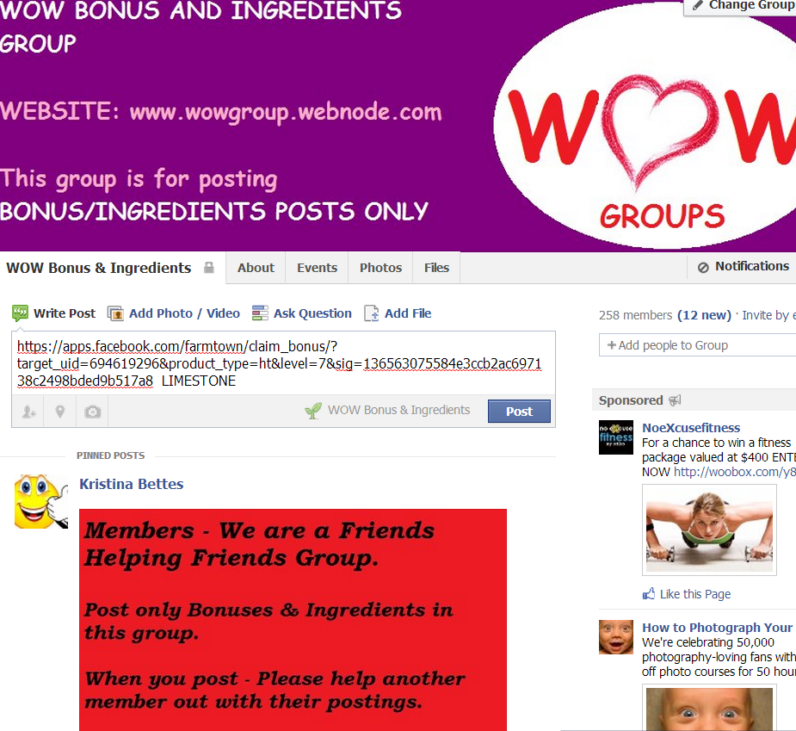

If you want to put multiple bonus/ facilities in the one post then just hit enter twice and then repeat the steps again or just click on the “blue post button” to post to the group

☺

